Annexure A – ANALYTICAL PROBLEM SOLVING
1. Given the input words: “connected”, “connecting”, “connection”, design a
morphological analysis pipeline for a document indexing system.
● Apply rules to decompose each word into root and suffix components.
● Differentiate between inflectional and derivational forms within the dataset.
● Normalize all variants to a common base form for efficient retrieval.
● Determine the parsed structure and normalized output for each word.
● Write a Python program to implement the above morphological analysis pipeline. The
program should accept the given input words, perform decomposition, classify each
suffix as inflectional or derivational, normalize the words to their common base form,
and display the parsed structure and normalized output in a tabular format.
Code:
print("MORPHOLOGICAL ANALYSIS")
print("-" * 70)
words = input("Enter words separated by space: ").lower().split()
results = []
for word in words:
if word == "connected":
root = "connect"
suffix = "ed"
suffix_type = "Inflectional"
normalized = "connect"
elif word == "connecting":
root = "connect"
suffix = "ing"
suffix_type = "Inflectional"
normalized = "connect"

elif word == "connection":
root = "connect"
suffix = "ion"
suffix_type = "Derivational"
normalized = "connect"
else:
root = word
suffix = "-"
suffix_type = "None"
normalized = word
results.append([word, root, suffix, suffix_type, normalized])
print("\n{:<15} {:<15} {:<10} {:<15} {:<15}".format(
"Word", "Root", "Suffix", "Type", "Normalized"
))
print("-" * 70)
for row in results:
print("{:<15} {:<15} {:<10} {:<15} {:<15}".format(*row))

Output:
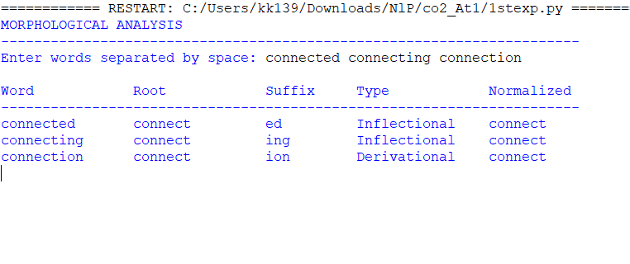

2.Given the input words: “unhappy”, “happiness”, “happily”, design a morphological
parsing module for sentiment analysis.
● Identify prefixes, suffixes, and base forms using rule-based decomposition.
● Ensure semantic consistency across derived word forms.
● Classify each transformation as inflectional or derivational.
● Produce the root and morphological breakdown for each word.
● Write a Python program to implement the above morphological parsing module. The
program should accept the given input words, identify the prefixes, suffixes, and base
forms, classify each transformation as inflectional or derivational, and display the
morphological breakdown and normalized root word in a tabular format.

Code:
print("MORPHOLOGICAL PARSING MODULE")
print("-" * 80)
words = input("Enter words separated by space: ").lower().split()
results = []
for word in words:
if word == "unhappy":
prefix = "un"
base = "happy"
suffix = "-"
transformation = "Derivational"
normalized = "happy"
elif word == "happiness":
prefix = "-"
base = "happy"
suffix = "ness"
transformation = "Derivational"
normalized = "happy"
elif word == "happily":
prefix = "-"
base = "happy"
suffix = "ly"
transformation = "Derivational"
normalized = "happy"
else:
prefix = "-"
base = word
suffix = "-"
transformation = "None"
normalized = word
breakdown = prefix + " + " + base + " + " + suffix
results.append([
word, prefix, base, suffix,
transformation, breakdown, normalized
])
print("\n{:<12} {:<10} {:<10} {:<10} {:<15} {:<25} {:<12}".format(
"Word", "Prefix", "Base", "Suffix",
"Type", "Breakdown", "Normalized"
))
print("-" * 100)
for row in results:
print("{:<12} {:<10} {:<10} {:<10} {:<15} {:<25} {:<12}".format(*row))

Output:
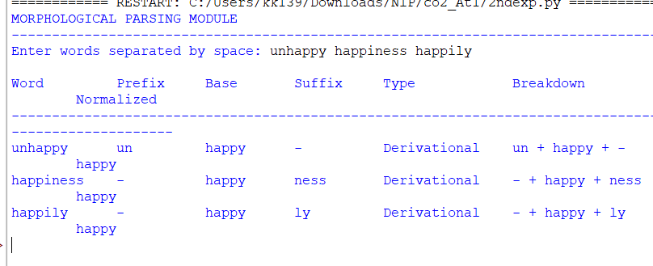
3. Given the input words: “played”, “player”, “playing”, design a stemming-based
preprocessing module for a search engine.
● Apply morphological rules to strip affixes and identify the base form.
● Handle both grammatical variations and word formation changes.
● Ensure consistent root extraction across all forms.
● Determine the stem and classification for each input word.
● Develop a Python program for a stemming-based preprocessing module used in a
search engine. The program should process the input words &quot;played&quot;, &quot;player&quot;, &quot;playing&quot;
by applying appropriate stemming rules to remove prefixes/suffixes where applicable,
identify the stem of each word, distinguish between grammatical inflections and word-
formation changes, and generate a structured output showing the original word,
extracted stem, removed affix (if any), transformation type (inflectional/derivational), and
the final normalized form suitable for indexing and information retrieval.

Code:
print("STEMMING-BASED PREPROCESSING MODULE")
print("-" * 85)
words = input("Enter words separated by space: ").lower().split()
results = []
for word in words:
if word == "played":
stem = "play"
affix = "ed"
transformation = "Inflectional"
normalized = "play"
elif word == "playing":
stem = "play"
affix = "ing"
transformation = "Inflectional"
normalized = "play"
elif word == "player":
stem = "play"
affix = "er"
transformation = "Derivational"
normalized = "play"
else:
stem = word
affix = "-"
transformation = "None"
normalized = word
results.append([
word, stem, affix, transformation, normalized
])
print("\n{:<15} {:<15} {:<15} {:<18} {:<15}".format(
"Original", "Stem", "Removed Affix",
"Transformation", "Normalized"
))

print("-" * 85)
for row in results:
print("{:<15} {:<15} {:<15} {:<18} {:<15}".format(*row))

Output:
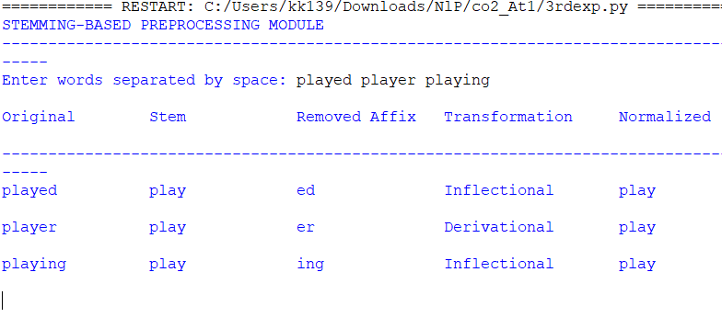
4. Given the input words: “writes”, “writing”, “written”, design a finite-state
morphological parsing module for a text processing system.
● Apply state transitions to represent suffix transformations and irregular forms in verb
inflection.
● Differentiate between regular and irregular inflectional patterns within the dataset.
● Ensure consistent mapping of all forms to a common root representation.
● Determine the state transitions, morphological breakdown, and normalized output for
each word.

● Develop a Python program that implements a finite-state morphological parser for the
input words &quot;writes&quot;, &quot;writing&quot;, &quot;written&quot;. The program should construct a finite-state
transition model to process regular suffixes and irregular verb forms, identify the
corresponding root word, classify each input as a regular or irregular inflection, trace the
sequence of state transitions during parsing, and display the state transition path,
morphological components, root form, and normalized representation for each input
word in a well-formatted output.
Code:
print("FINITE-STATE MORPHOLOGICAL PARSER")
print("=" * 100)
words = input("Enter words separated by space: ").lower().split()
results = []
for word in words:
if word == "writes":
path = "q0 -> q1 -> q2 -> q3 -> q4"
breakdown = "write + s"
root = "write"
classification = "Regular Inflection"
normalized = "write"

elif word == "writing":
path = "q0 -> q1 -> q2 -> q3 -> q5"
breakdown = "write + ing"
root = "write"
classification = "Regular Inflection"
normalized = "write"
elif word == "written":
path = "q0 -> q1 -> q6 -> q7"
breakdown = "write -> written"
root = "write"
classification = "Irregular Inflection"
normalized = "write"
else:

path = "q0"
breakdown = word
root = word
classification = "Unknown"
normalized = word

results.append([
word,
path,
breakdown,
root,
classification,
normalized
])

print("\n{:<12} {:<30} {:<22} {:<12} {:<20} {:<12}".format(
"Word",
"State Path",
"Morphological Breakdown",
"Root",
"Classification",
"Normalized"
))

print("-" * 120)
for row in results:
print("{:<12} {:<30} {:<22} {:<12} {:<20} {:<12}".format(*row))

Output:
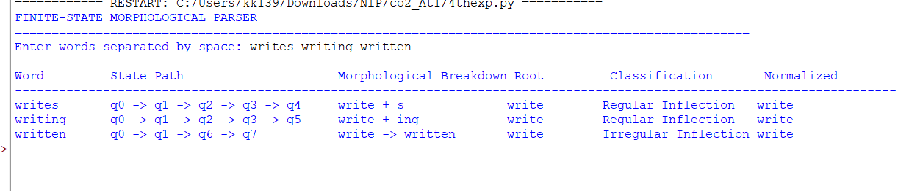

5. Given the input words: “relational”, “relation”, “relate”, design a Porter Stemmer-
based preprocessing module for document retrieval.
● Apply stemming rules step-by-step to remove derivational suffixes and obtain base
forms.
● Handle variations in suffix patterns while preserving semantic consistency.
● Ensure uniform root extraction across all derived forms.
● Determine the stemming steps, intermediate forms, and final stem for each input word.
● Develop a Python program that implements the Porter Stemming algorithm for the input
words &quot;relational&quot;, &quot;relation&quot;, &quot;relate&quot;. The program should apply the Porter stemming
rules sequentially to remove derivational suffixes, display the intermediate form
obtained after each stemming step, handle different suffix patterns while preserving the
word meaning, and generate the final stem for each word. The output should clearly
present the original word, applied stemming rule(s), intermediate forms, and the final
normalized stem in a structured format suitable for document retrieval applications.

Code:
print("PORTER STEMMER BASED PREPROCESSING")
print("=" * 80)
words = input("Enter words separated by space: ").lower().split()
def porter_stem(word):
steps = []
original = word
# Step 1: Remove -al
if word.endswith("al"):
word = word[:-2]
steps.append("Remove 'al' -> " + word)

# Step 2: Remove -ion
if word.endswith("ion"):
word = word[:-3]
steps.append("Remove 'ion' -> " + word)

# Step 3: Remove final e
if word.endswith("e") and len(word) > 3:
word = word[:-1]
steps.append("Remove final 'e' -> " + word)

return original, steps, word
results = []
for word in words:
original, steps, final_stem = porter_stem(word)

if len(steps) == 0:
rule = "No rule applied"
intermediate = word
else:
rule = "; ".join(steps)
intermediate = " -> ".join(
[x.split("->")[1].strip() for x in steps]
)

results.append([
original,
rule,
intermediate,
final_stem
])

print("\n{:<15} {:<45} {:<25} {:<15}".format(
"Original",
"Applied Rule(s)",
"Intermediate Forms",
"Final Stem"
))

print("-" * 105)
for row in results:
print("{:<15} {:<45} {:<25} {:<15}".format(*row))

Output:
